## **Question 1:**

You develop an app that allows users to upload photos and videos to Azure storage. The app uses a storage REST API call to upload the media to a blob storage account named Account1. You have blob storage containers named Container1 and Container2. Uploading of videos occurs on an irregular basis. You need to copy specific blobs from Container1 to Container2 in real time when specific requirements are met, excluding backup blob copies. What should you do?

1. Download the blob to a virtual machine and then upload the blob to Container2.
2. Run the Azure PowerShell command Start-AzureStorageBlobCopy.
3. Copy blobs to Container2 by using the Put Blob operation of the Blob Service REST API.
4. Use AzCopy with the Snapshot switch blobs to Container2.

**Correct Answer:**

**B**

**Explanation:**

The Start-AzureStorageBlobCopy cmdlet starts to copy a blob.

Example 1: Copy a named blob C:\PS>Start-AzureStorageBlobCopy -SrcBlob "ContosoPlanning2015" -DestContainer "ContosoArchives" -SrcContainer "ContosoUploads"

This command starts the copy operation of the **blob** named **ContosoPlanning2015** from the container named **ContosoUploads** to the container named **ContosoArchives.**

References: <https://docs.microsoft.com/en-us/powershell/module/azure.storage/start-azurestorageblobcopy?view=azurermps>

## **Question 2:**

You are developing an application that uses Azure Blob storage.  
The application must read the transaction logs of all the changes that occur to the blobs and the blob metadata in the storage account for auditing purposes. The changes must be in the order in which they occurred, include only create, update, delete, and copy operations and be retained for compliance reasons. You need to process the transaction logs asynchronously.  
What should you do?

1. Process all Azure Blob storage events by using Azure Event Grid with a subscriber Azure Function app.
2. Enable the change feed on the storage account and process all changes for available events.
3. Process all Azure Storage Analytics logs for successful blob events.
4. Use the Azure Monitor HTTP Data Collector API and scan the request body for successful blob events.

**Correct Answer:**

**B**

**Explanation:**

Change feed support in Azure Blob Storage

The purpose of the change feed is to provide transaction logs of all the changes that occur to the blobs and the blob metadata in your storage account. The change feed provides ordered, guaranteed, durable, immutable, read-only log of these changes. Client applications can read these logs at any time, either in streaming or in batch mode. The change feed enables you to build efficient and scalable solutions that process change events that occur in your Blob Storage account at a low cost.  
Reference:  
<https://docs.microsoft.com/en-us/azure/storage/blobs/storage-blob-change-feed>

## **Question 3:**

You are developing an application to use Azure Blob storage. You have configured Azure Blob storage to include change feeds.

* A copy of your storage account must be created in another region.
* Data must be copied from the current storage account to the new storage account directly between the storage servers.
* You need to create a copy of the storage account in another region and copy the data.

In which order should you perform the actions?

To answer, move all actions from the list of actions to the answer area and arrange them in the correct order.  
Select and Place:

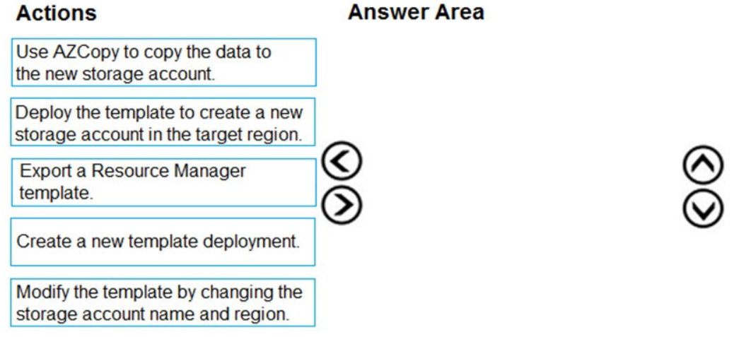

**Correct Answer:**

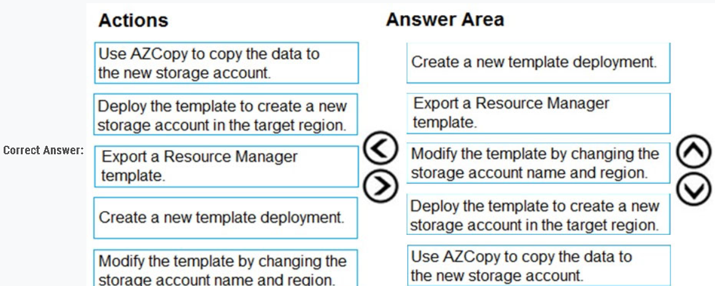

**Explanation:**

To move a storage account, create a copy of your storage account in another region. Then, move your data to that account by using AzCopy, or another tool of your choice.  
The steps are:  
✑ Export a template.  
✑ Modify the template by adding the target region and storage account name.  
✑ Deploy the template to create the new storage account.  
✑ Configure the new storage account.  
✑ Move data to the new storage account.  
✑ Delete the resources in the source region.

**Note:** You must enable the change feed on your storage account to begin capturing and recording changes. You can enable and disable changes by using Azure Resource Manager templates on Portal or Powershell.  
Reference:  
https://docs.microsoft.com/en-us/azure/storage/common/storage-account-move <https://docs.microsoft.com/en-us/azure/storage/blobs/storage-blob-change-feed>

## **Question 4:**

You develop a website. You plan to host the website in Azure. You expect the website to experience high traffic volumes after it is published.  
You must ensure that the website remains available and responsive while minimizing cost.  
You need to deploy the website.  
What should you do?

1. Deploy the website to a virtual machine. Configure the virtual machine to automatically scale when the CPU load is high.
2. Deploy the website to an App Service that uses the Shared service tier. Configure the App Service plan to automatically scale when the CPU load is high.
3. Deploy the website to a virtual machine. Configure a Scale Set to increase the virtual machine instance count when the CPU load is high.
4. Deploy the website to an App Service that uses the Standard service tier. Configure the App Service plan to automatically scale when the CPU load is high.

**Correct Answer:**

**D**

**Explanation :**  
Windows Azure Web Sites (WAWS) offers 3 modes: **Standard, Free, and Shared**.  
Standard mode carries an enterprise-grade SLA (Service Level Agreement) of 99.9% monthly, even for sites with just one instance.  
Standard mode runs on dedicated instances, making it different from the other ways to buy Windows Azure Web Sites.

**Incorrect Answers:**  
B: Shared and Free modes do not offer the scaling flexibility of Standard, and they have some important limits.  
Shared mode, just as the name states, also uses shared Compute resources, and also has a CPU limit. So, while neither Free nor Shared is likely to be the best choice for your production environment due to these limits.

## **Question 5:**

You develop Azure solutions.  
You must connect to a No-SQL globally-distributed database by using the .NET API.  
You need to create an object to configure and execute requests in the database.  
**Which code segment should you use?**

1. new Container(EndpointUri, PrimaryKey);
2. new Database(EndpointUri, PrimaryKey);
3. new CosmosClient(EndpointUri, PrimaryKey);

**Correct Answer:**

**C**

**Example:**  
// Create a new instance of the Cosmos Client  
this.cosmosClient = new CosmosClient(EndpointUri, PrimaryKey)  
//ADD THIS PART TO YOUR CODE  
await this.CreateDatabaseAsync();

Reference:  
<https://docs.microsoft.com/en-us/azure/cosmos-db/sql-api-get-started>

## **Question 6:**

A company is developing a solution that allows smart refrigerators to send temperature information to a central location. You have an existing Service Bus.  
The solution must receive and store messages until they can be processed. You create an Azure Service Bus instance by providing a name, pricing tier, subscription, resource group, and location.  
You need to complete the configuration.  
Which Azure CLI or PowerShell command should you run?  
A.  
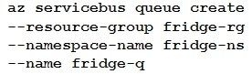  
B.  
  
C.  
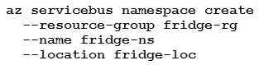  
D.  
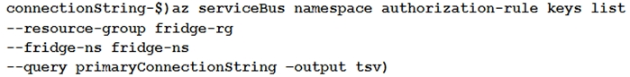

**Correct Answer:**

**A**

**Explanation**

A service bus instance has already been created (Step 2 below). Next is step 3, Create a Service Bus queue.  
**Note:**  
Steps:  
**Step 1: # Create a resource group**  
resourceGroupName="myResourceGroup"  
az group create --name $resourceGroupName --location eastus  
**Step 2: # Create a Service Bus messaging namespace with a unique name** namespaceName=myNameSpace$RANDOM az servicebus namespace create --resource-group $resourceGroupName --name $namespaceName --location eastus  
**Step 3: # Create a Service Bus queue**  
az servicebus queue create --resource-group $resourceGroupName --namespace-name $namespaceName --name BasicQueue  
**Step 4: # Get the connection string for the namespace**  
connectionString=$(az servicebus namespace authorization-rule keys list --resource-group $resourceGroupName --namespace-name $namespaceName --name  
RootManageSharedAccessKey --query primaryConnectionString --output tsv)

Reference:  
<https://docs.microsoft.com/en-us/azure/service-bus-messaging/service-bus-quickstart-cli>

You are developing a solution that will use Azure messaging services.  
You need to ensure that the solution uses a publish-subscribe model and eliminates the need for constant polling.  
What are two possible ways to achieve the goal? Each correct answer presents a complete solution.  
NOTE: Each correct selection is worth one point.

* A. Service Bus
* B. Event Hub
* C. Event Grid
* D. Queue

**Correct Answer:**

***AC***

**Explanation**

It is strongly recommended to use available messaging products and services that support a publish-subscribe model, rather than building your own. In Azure, consider using Service Bus or Event Grid. Other technologies that can be used for pub/sub messaging include Redis, RabbitMQ, and Apache Kafka.  
Reference:  
<https://docs.microsoft.com/en-us/azure/architecture/patterns/publisher-subscriber>

## **Question 7:**

You are developing an Azure Service application that processes queue data when it receives a message from a mobile application. Messages may not be sent to the service consistently.  
You have the following requirements:

**✑ Queue size must not grow larger than 80 gigabytes (GB).  
✑ Use first-in-first-out (FIFO) ordering of messages.  
✑ Minimize Azure costs.**

You need to implement the messaging solution.  
**Solution: Use the .Net API to add a message to an Azure Storage** **Queue from the mobile application. Create an Azure VM that is triggered from Azure Storage**  
Queue events.  
**Does the solution meet the goal?**

1. Yes
2. No

**Correct Answer:** ***B***  
Don't use a VM, instead create an Azure Function App that uses an Azure Service Bus Queue trigger.

Reference:

<https://docs.microsoft.com/en-us/azure/azure-functions/functions-create-storage-queue-triggered-function>